Contents

1. Initialize & Database: 2

a. Menu: 2

b. User Define Table: 2

c. User Define Field: 2

d. SQL Store Procedures and Functions 2

2. GST Setup: 3

a. AP Bad Debt: 3

b. AR Bad Debt: 3

c. General: 4

d. Reverse Mechanism: 4

3. GST Reports 5

a. GST-03 Report: 5

b. GST Detail Report: 5

4. GST File Export 6

5. Payment Contra 6

6. Reverse Mechanism 6

7. Outstanding Delivery Order 21 days rule 6

8. GST AR Bad Debt 6

9. GST AP Bad Debt: 8

# Initialize & Database:

## Menu:

* + Administration 🡺 Setup 🡺 Financial 🡺 GST Setup
  + Administration 🡺 Setup 🡺 Financial 🡺 GST Heath Check
  + Financial 🡺 GST
  + Financial 🡺 GST 🡺 GST File Export
  + Financial 🡺 GST 🡺 Outstanding Delivery Order
  + Financial 🡺 GST 🡺 Payment Contra
  + Financial 🡺 GST 🡺 Reverse Mechanism Report
  + Financial 🡺 GST 🡺 GST Reports
  + Financial 🡺 GST 🡺 GST Reports 🡺 GST-03 Report
  + Financial 🡺 GST 🡺 GST Reports GST Detail Report
  + Financial 🡺 GST 🡺 GST Bad Debt
  + Financial 🡺 GST 🡺 GST Bad Debt 🡺 GST AR Bad Debt Relief
  + Financial 🡺 GST 🡺 GST Bad Debt 🡺 GST AP Bad Debt Relief

## User Define Table:

* + @GSTSETUP
  + @GST_MSIC

## User Define Field:

* + Marketing Documents Title:
    - U_BadDebt
    - U_BadDebtJE
    - U_21Day
    - U_21DayJE
  + Journal Entry header:
    - U_21Day
    - U_BadDebt
    - U_ContraPayment
  + Journal Entry row:
    - U_InvoiceEntry
  + @GSTSETUP
    - U_Value
  + @MSIC
    - U_MSICCode
    - U_PERCENTAGE

## SQL Store Procedures and Functions

* + uf_GetTaxBalance
  + uf_GetTaxBalance_AP
  + Generate Store procedure:
  + sp_SAPB1Addon_GST03
  + sp_B1Addon_BadDebtReverse
  + sp_B1Addon_BadDebtReverse_AP
  + sp_SAPB1Addon_GSTBadDebt
  + sp_SAPB1Addon_GSTBadDebt_AP
  + sp_B1Addon_GAF
  + sp_B1Addon_GAFtxt
  + sp_B1Addon_GSTReturn
  + sp_SAPB1Addon_PaymentContra
  + sp_SAPB1Addon_21DO

# GST Setup:

## AP Bad Debt:

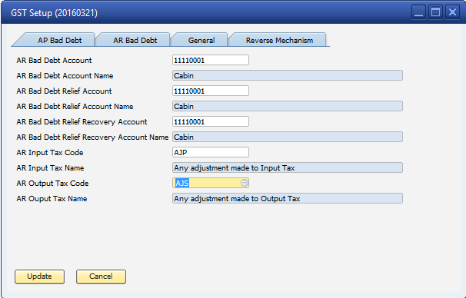

## AR Bad Debt:

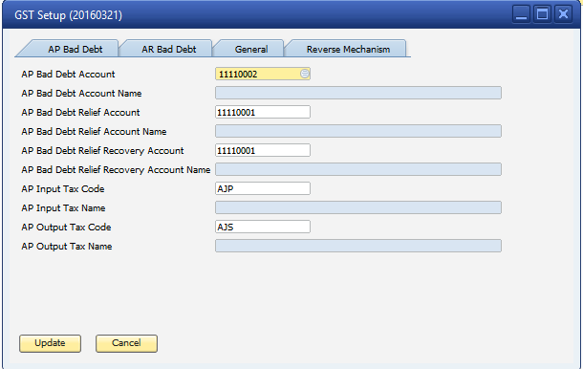

## General:

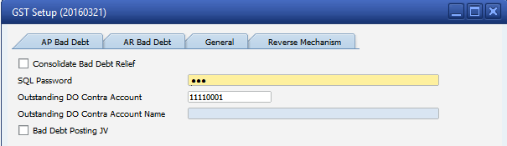

## Reverse Mechanism:

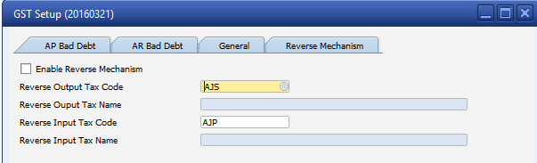

# GST Reports

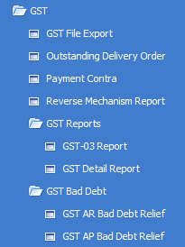

**\*\* Note:**

1. **You must setup SQL Password in GST Setup to use this feature.**
2. **The GST Code is getting from Report Code column in VAT Group. So this column need to be filled.**

**\*\*Tech:**

1. **The crystal reports are built-in in the addon. There’s no need to import crystal report**

**\*\*Design:**

1. **Data is getting from SAP View: dbo.B1_VatView, store name is used: sp_SAPB1Addon_GST03**

Menu path: Financial\GST\GST Reports. There are 2 reports:

## GST-03 Report:

* + Report Parameter:

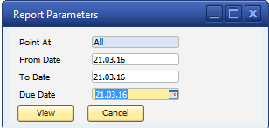

* + Check Outstanding DO:
  + Report viewer

## GST Detail Report:

* + Report Parameter

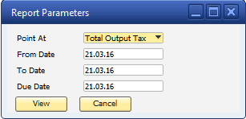

* + Report Viewer

# GST File Export

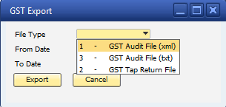

# Payment Contra

# Reverse Mechanism

# Outstanding Delivery Order 21 days rule

* Calling store: sp_SAPB1Addon_21DO
* Logic: Listing the open delivery Note which has
  + Status of posting 21 days is NO
  + Day different from selected date to posting date greater than or equal 21 days
  + Has open tax balance on delivery note.

(sum(DLN1."VatSum"* DLN1."OpenQty"/ DLN1."Quantity")<>0)

# GST AR Bad Debt

* Calling store: sp_SAPB1Addon_GSTBadDebt
* Logic: listing the Invoice (OINV) which has different from posting to current date (Server’s Date) greater than 6 (parameter)
* Supported SQL And Hana version

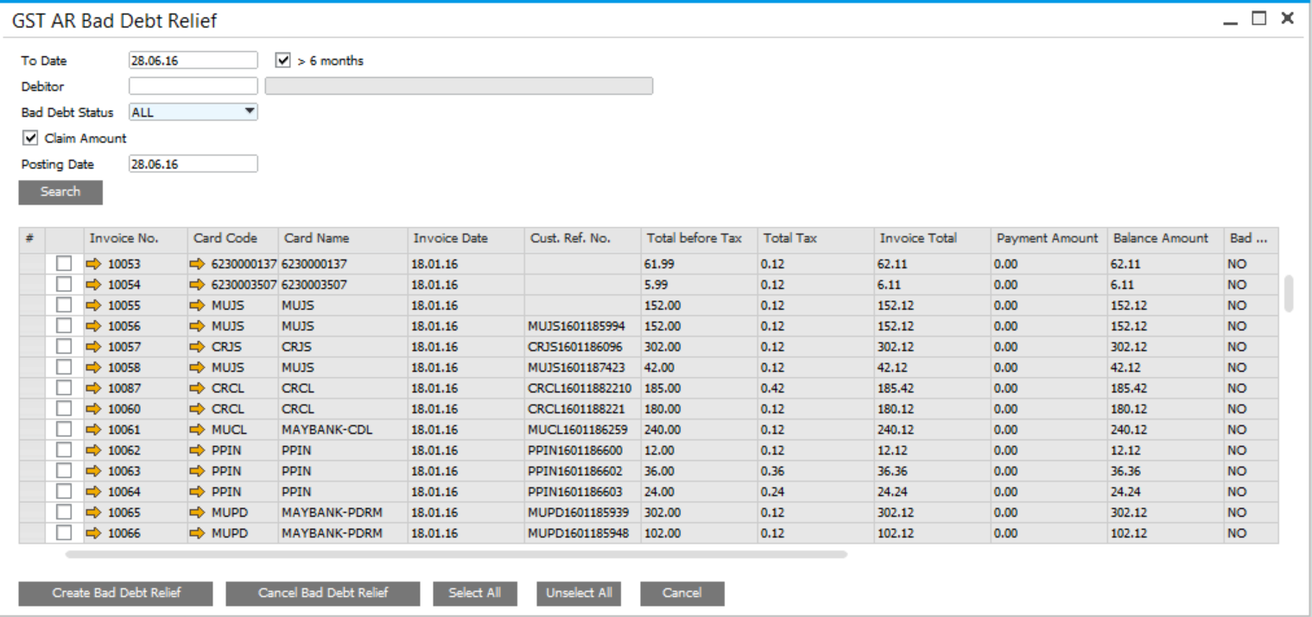

* If the Incoming Payment is created against AR which is flagged as BadDebt, then a JE is created to reverse the Bad Debt Entry

Create Bad Debt Relief Button:

* If the option “Consolidate Bad Debt Relief” is enable

(@GSTSETUP. U_Value= Y, Code=OneJE)

* Then only 1 JE is created from selected invoices, otherwise different JE is created for each selected invoice.
* Update the status of invoice: OINV.U_BadDebt=Y and OINV.U_BadDebtJE = Created JE No.
* Bad Debt JE Information: OJDT.U_BadDebt=Y, JDT1.U_InvoiceEntry=Selected Invoice Num.

Debit: Input Tax for AR (GST Setup)

Credit: AR Bad Debt Relief Account (GST Setup)

Amount: tax balance (calling function uf_GetTaxBalance)

Cancel Bad Debt Relief button:

# GST AP Bad Debt:

